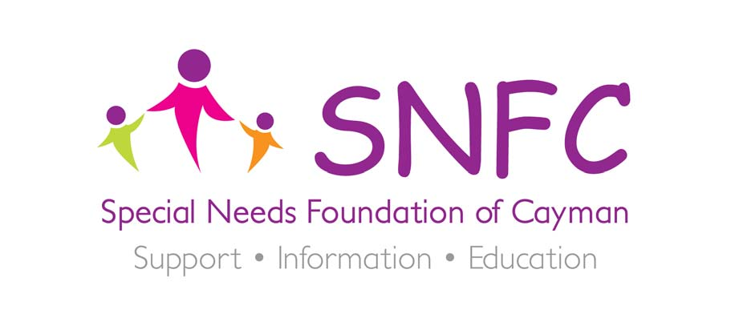

Dear Sir/Madam

The Special Needs Foundation is delighted that Mr Derek Haines has agreed to take part in our 50/50 challenge to raise funds for our charity.

The Special Needs Foundation of Cayman is a non-profit organization of parents, educators and professionals committed to supporting children with a range of special needs across the Cayman Islands. We are dedicated to the development and provision of appropriate and comprehensive support services.

Through the 50/50 Campaign we intend to raise $50,000 towards four of our most successful programmes, namely the:

- Respite Care Programme $10,000
- Equine Therapy Scholarship Programme $15,000
- Family Support Programme $10,000
- Sports & Leisure Club $15,000

The philosophy of the 50/50 platform was built on the “collective capacity of a group of passionate people to create influence in our community.” In the case of 50/50, it is the power and endless capabilities of 50 super heroes who are committed to joining forces in a number of creative ways to make a significant impact to the lives of individuals with Special Needs and their families.

On the 6th of December 2015, 50 committed runners or ‘super heroes’ will line the streets of George Town ready to take part in a movement that will widen the scope of services available to those with special needs in our community. As you will undoubtedly be aware, Mr Haines has proven to be the most committed charity runner of the Cayman Islands and the Special Needs Foundation are excited that he has agreed to join us.

As a non-profit charity we gain all our funds from donations; all monies received go towards services for children and their families. No expenses or admin fees are taken.

We do hope that you will consider sponsoring Mr Haines as one of our 50 ‘super heroes’ as he tries to support the special needs community.

Kind regards

Susie Bodden
Executive Leader - The Special Needs Foundation of Cayman
Chartered Educational Psychologist - CPsychol, BSc (Hons), PGCE, MPhil, MSc

